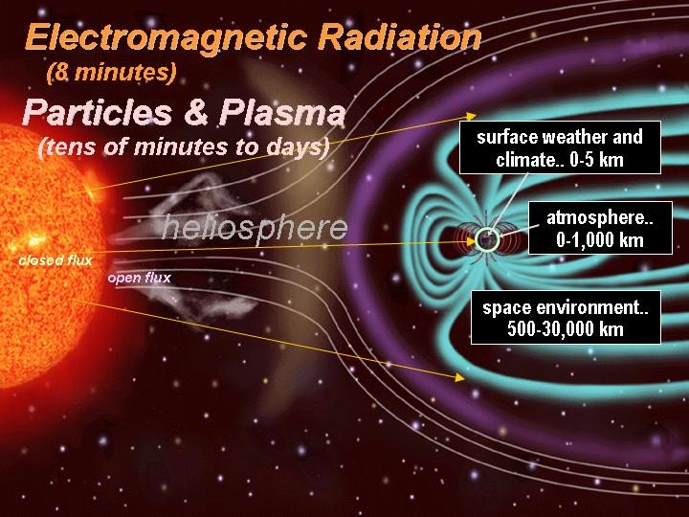
Fall Semester, 2005
CSI 769 /ASTR 769
Topics in Space Weather
Prerequisites: permission of instructor.
Credits: 3
Description:
Space Weather is a new field of science that studies the space environment driven by the interaction between the Sun and the Earth. Space Weather can adversely affect humans and human technology, including astronauts, satellites (systems and orbits), communications and navigation, electric power grids, and pipelines. This course begins with an overview of the space weather systems involving the Sun, Heliosphere, Magnetosphere and Ionosphere. Physical processes in the solar atmosphere are the ultimate drivers of space weather. We will present the basic structure of the Sun, the solar magnetic field and configuration, the physical bases of flares and coronal mass ejections, and particle acceleration mechanisms. The various forms of particle and field outflow are traced throughout interplanetary space. Interactions of the solar wind with solar system bodies and the transition to the nearby interstellar medium are covered. Together, the Sun and heliosphere form the boundary conditions for establishing the physical state of the near-Earth space system, including the upper atmosphere.
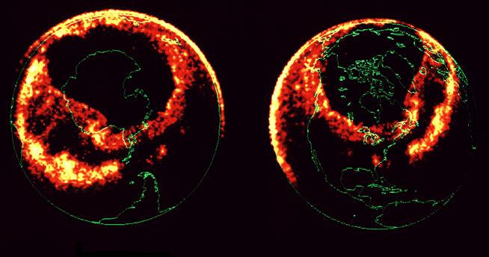
The outermost magnetized region surrounding the Earth is the magnetosphere. The solar wind causes the Earth’s dipole-like field to be distorted and elongated. The outermost field lines are highly variable, depending on the conditions of the solar wind. The physical processes that govern the magnetosphere’s behavior and its interaction with the atmosphere will be covered. These include electric fields and particle acceleration that can produce geomagnetic storms. The ground state of the upper atmosphere is established primarily by solar radiation. The fundamental equations of state that dictate atmospheric equilibrium and the creation of the ionosphere will be presented. Basic processes include neutral gas dynamics, ionospheric motions, and photochemical processes. Some aspects of non-thermal radiation transport and spectroscopy will be covered as background material for understanding remote sensing of the near-Earth space environment, a new tool for understanding space weather on a global-scale.

Instructors: Art Poland, Jie Zhang (Sun), Merav Opher (Heliosphere), John Guillory (Magnetosphere), Bob Meier (Ionosphere)

Class meets: 7:20 PM to 10:00 PM, Tuesday, Enterprise Hall 76

